 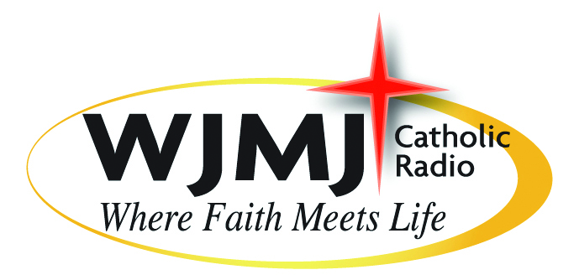 **A Nationwide Emergency Alert System Test Will Take Place On November 9, 2011**

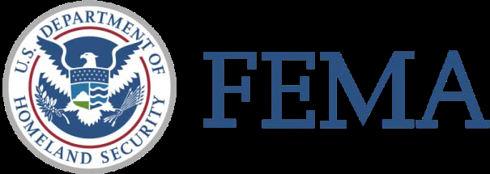

The U.S. Department of Homeland Security's Federal Emergency Management Agency (FEMA) and the Federal Communications Commission (FCC), the National Oceanic and Atmospheric Administration (NOAA) will conduct the first nationwide test of the Emergency Alert System (EAS). The nationwide test will occur on Wednesday, November 9 at 2 p.m. eastern time and may last up to three and a half minutes. The public will hear a message indicating that "This is a test.” The audio message will be the same for radio, television, and cable. The National-level EAS is a public alert and warning system that enables the President of the United States to address the American public during extreme emergencies. Similar to local EAS tests that are conducted frequently, the Nationwide Test will involve broadcast radio and television stations, cable television, satellite radio and television services and wireline providers across all states and territories. Over the past two years and as part of ongoing national preparedness planning efforts, FEMA, the FCC and other federal partners, State, local, tribal and territorial governments, EAS Participants, and others in the EAS Community have been working toward making this test a reality. As the federal, state, tribal, territorial and local governments prepare for and test their capabilities; this event serves as a reminder that everyone should establish an emergency preparedness kit and emergency plan for themselves, their families, communities, and businesses. Anyone can visit [www.Ready.gov](http://www.Ready.gov) for more information about how to prepare for and stay informed about what to do in the event of an actual emergency.

**Role of the EAS**

As part of the Federal Emergency Management Agency’s (FEMA) larger efforts to strengthen our nation’s preparedness and resiliency, FEMA and the Federal Communications Commission (FCC) announced that we will conduct the first national-level test of the Emergency Alert System on November 9th, 2011 at 2:00 PM ET.

Similar to the way local emergency alert system tests are conducted, the nationwide test will simultaneously involve television stations (including digital television, cable, satellite audio and television services) and broadcast radio stations across the U.S. and several U.S. territories (Puerto Rico, Virgin Islands, America Samoa).

The EAS has never been tested on a national level before, and conducting this test is an opportunity to baseline the system and its capabilities at all levels. The EAS test plays a key role in ensuring our nation is prepared for all hazards and that the public is able to receive critical and vital information, should it ever be needed.

While EAS tests may be temporarily disruptive to radio and television programming, they are important to ensure that the EAS is functional.

**Key Messages**

1. The U.S. Department of Homeland Security's Federal Emergency Management Agency (FEMA) and the Federal Communications Commission (FCC) will conduct the first nationwide test of the Emergency Alert System (EAS) on Wednesday, November 9 at 2:00 p.m. (Eastern) and may last up to three and a half minutes.
2. On November 9, the public will hear a message indicating that "This is a test.” The audio message will be the same for both radio and television.
3. A Nationwide EAS Test will help the federal partners and EAS participants determine the reliability of the system and its effectiveness in notifying the public of emergencies and potential dangers nationally and regionally.
4. As the Federal, State, tribal, territorial and local governments prepare for and test their capabilities, this event serves as a reminder that everyone should establish an emergency preparedness kit and emergency plan for themselves, their families, communities, and businesses.
5. Anyone can visit [www.Ready.gov](http://www.Ready.gov) for more information about how to prepare for and stay informed about what to do in the event of an actual emergency.

**Frequently Asked Questions: Nationwide Emergency Alert System Test**

**What is the Emergency Alert System (EAS)?**

The National-level EAS is a national public alert and warning system that enables the President of the United States to address the American public during extreme emergencies. Alerting authorities can leverage the State and local EAS to send alerts and warnings to radio and television stations, cable television, satellite radio and television services and wireline providers.

**What is Nationwide Emergency Alert System (EAS) Test?**

The Federal Emergency Management Agency (FEMA,) in coordination with the Federal Communications Commission (FCC) and the National Oceanic and Atmospheric Administration (NOAA), will send an EAS test message to all participating radio, television, cable, and satellite providers.

**What Can I Expect to Hear/See?**

The Test may look like regular, local EAS tests that most people are already familiar with, but there will be some differences in what viewers will see and hear. The audio message will repeat “This is a test.” The video message scroll may not indicate “This is a test.” The message will last for approximately three minutes and then regular programming will resume.

**Where Will I Hear/See the Test?**

On all participating radio, television, cable, and satellite providers (who are called EAS Participants).

**When Will the Test Occur?**

November 9, 2011 at 2:00 PM (Eastern). The 2:00 PM (Eastern) time was selected to make sure the Test can occur during normal business hours across many time zones.

<http://www.fema.gov/emergency/ipaws/eas_info.shtm>